**The North American River Otter: The Good, The Bad, and The Future**

Author: Braden T Farris

**Introduction**

For the past three months I have participated in a camera trapping research project. A mammal that the cameras continually caught was the river otter on the shores of Lake Taneycomo. This piqued my interest, since I was not even aware of a population of river otters on Taneycomo. It turns out there is a long saga surrounding the river otter, not just in Missouri, but in the entire Midwest. My audience is the people of Missouri who have encountered otters in some way or another, whether it be good or bad and whether you are a private landowner, business owner, or government official. My hope is to make you understand the river otter and their importance in Missouri. I am hoping to educate my audience about the river otter, from an ecological and economical perspective, and maybe even convince you that the river otter is a needed and deserving creature in our rivers and streams and that there is a way that they can be managed that can benefit both them and us humans. I am writing on behalf of *The Great American West*, a blog that is dedicated towards the ecology of the western United States, where the river otter is found as well.

*Photo courtesy of Jim Rathert, MDC*

**Scientific Description of the River Otter**

The North American River Otter (*Lontra canadensis*) is in the weasel family (Mustelidae) which is in the order Carnivora according to the *Missouri Department of Conservation Otter fact page (2018)*. The river otter has webbed feet, long tapered tails, thick oily fur, layers of warmth producing fat, long whiskers for sensory purposes, and a keen sense of smell. They are powerful swimmers and can be submerged underwater for over three minutes. Otters are carnivores and feed upon crustaceans, fish, and small mammals.

**Ecological Explanation of the River Otter's Abundance**

The river otter's abundance can be determined by several spatial factors. According to a scientific study done by *The American Midland Naturalist titled, "Scale-dependent Factors Affecting North American River Otter Distribution in the Midwest" (2011)*, an otter's population can be attributed to water quality, fish abundance, riparian cover, and seasonal predator abundance. There is conclusive scientific research that points out that healthy river otter populations may depend on these scale-dependent factors. It became conclusive by the end of the study done by The American Midland Naturalist that otters prefer wooded riparian zones three out of four times compared to grass or cropland landscape. Lake Taneycomo is a heavily forested riparian zone, so it makes sense why there is such a heavy population. Another interesting find is that otters will be present in an environment, if the environment sustains a beaver population. It was proven by my group's trail camera survey that both beavers and otters are present on the College of the Ozarks campus on Taneycomo. Taneycomo also sustains a very healthy trout population, which is why the otters stay on the lake year round. The seasonal predator abundance that was observed by the trail camera suggest there are at least two bobcats where the otters are spotted on the shores of Taneycomo, but there is no evidence of the bobcats having a predatory influence on the otters. With unlimited fish, good quality forested cover, clean water, and limited predatory factors, it makes perfect ecological sense why the river otter has made Lake Taneycomo and the surrounding area a permanent home.

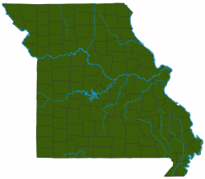**Conservation History** *Image courtesy of MDC*

According to the *Missouri Department of Conservation Missouri River Otter Saga page (2007)*, there were only 35-70 river otters alive in the state of Missouri in 1980, all of them located in the wetlands of the far southeast boot hill region. Since the restocking efforts of the department took place, there are now well over 15,000 otters in the state, located in every county of Missouri. During an eleven year period 845 otters were released, and the population has exploded since then. The otter conservation efforts have truly been a success story, but now there are thoughts that it has been too successful. *These issues will be addressed shortly.*

The current status of the river otter in Missouri is estimated at around 10,000 otters, which is the goal of MDC. The population peaked at 18,000, which is when angler complaints were at an all-time high. Now since trapping has been implemented for over 15 years, population of river otters has declined and anglers do not complain as much. The map below indicates that every county in Missouri has a river otter population.

**Wildlife Policy of Missouri River Otters**

According to the *Missouri Department of Conservation Otter Control page (2018)*, the otter is classified as a furbearer and therefore can be trapped during the trapping season dates. The code also states that any harmful otter can be shot or trapped not during furbearer season without a permit. This code refers to private landowners whose property is being harmed or whose personal health is in danger due to otters. Out of season permits are most used by farmers who have ponds, where otters come in and can wipe out a population quickly, or for business owners along a river where otters are detrimental to business.

**Economic Value of River Otters**

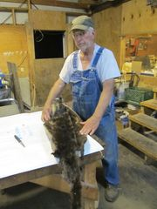The economic value of otters can be traced directly back to their pelts, like any other furbearer. According to a *News Tribune Article "A Whole Otter Trouble" (2018)*, there is actually quite a large market for otter pelts. Tyler Brown, a game warden of Missouri, says a fur market for otters creates a natural otter control which utilizes trapping, and it helps keep in check the population. *The MDC Missouri Otter Saga page (2007)* relays that trapping numbers of otters has increased due to the pelt market value. In 2006 there were 3,000 otters trapped in Missouri, with the market at a high of $40-$120 per pelt. That equates to $120,000-$360,000 circulating in Missouri alone for otter pelts.

*Photo courtesy of Ken White, Springfield News-Leader*

**River Otter Nuisance**

Around the state of Missouri, there have been complaints by private landowners and businesses in close proximity to bodies of water. The *News Tribune Article "A Whole Otter Trouble" (2018)* refers to the Osage Cat fisheries business, which supplies 32 fish species to private and public bodies of water around the state. The business states that otters have wiped out entire ponds and have cost the business valuable money. They equate the otter with feral pigs and coyotes, and say that they should not have been reintroduced.

A *Springfield News-Leader article titled, "Otters may be cute and playful, but they pose a threat to fishing"(2015)* focuses on the otters effect on a private landowner’s fish population. Rick Snelson bought a property in Missouri just for the purpose of fishing, and then otters came along. Snelson says that in a matter of months all of the fish in all of his ponds had been killed or eaten by a group of otters. He has restocked them multiple times, but the otters come back and eat them again. Later in the article a marina on Stockton Lake owned by Dan Howard experienced fishing woes in the winter. During the winter fish are more vulnerable, and this is usually when otters feast around marinas. Howard says that trapping has helped, but it continues to be a problem.

A story as recent as August 17, 2018 talks about the otter problem on Lake Taneycomo. According to an *AP article titled "Wild otters causing grief for some Missouri anglers"(2018)*, there are two marinas located off the Branson Landing that have experienced harmful otter behavior to their businesses. At Lilley's Landing the otters have been eating caught trout right off the hook of fisherman, and at Scotty's Trout Dock otters have climbed onto boats and ripped apart seats and cushions with their sharp teeth. 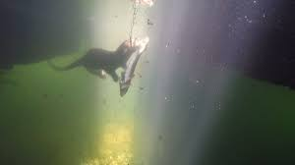Another problem both marinas have experienced is that otters will come up onto the docks and boats and leave feces behind, to mark their territory. The otters have also left behind fish carcasses behind, which leave an unpleasant smell for customers. Lamar Patton, the owner of Scotty's Trout Dock, filed for a nuisance control license and has killed about three dozen otters of the years with a trap. Since it's a nuisance control license Patton cannot sell the pelts, but he is happy anyways because the otter trapping is controlling the otter problem. Pictured below is a river otter in Taneycomo, wrestling away a trout from a fisherman.

*Photo courtesy of KY3 News*

**Social Media Attention towards Otters**

Social media is a good way to determine how the general public feels about a topic, at least with the younger generations. The *#riverotter on Twitter (2017)* produces thousands of results on the social media platform. After scrolling through numerous pages, the overall tone towards river otters is quite clear. People who use #riverotter are normal people, conservationists, and government entities, and all of them have a positive message about the river otter. These messages draw attention to the cuteness of the river otter and it also drive the importance of the river otter in America's rivers. This drives home that the wildlife departments of both state and federal levels, normal people who have no wildlife background, and scientists all have positive views of the river otter. This may indicate that people who complain about river otters are not extremely vocal about their disdain for them and that they are of older generations.

The complaints of otters from landowners and business owners towards wildlife agencies does not reflect in social media. It is also worthy to note that there has been no organization or outcry calling for the extermination of the otter, such as for the feral pig.

*Photo courtesy of Jim Rathert, MDC*

**Call to Action**

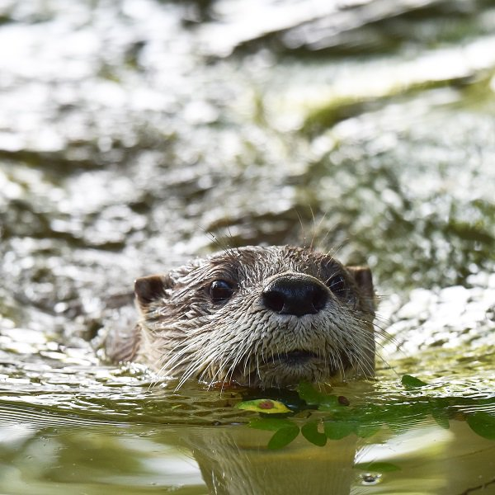It is overwhelmingly apparent that the river otter's stay in Missouri is in for the long haul. It has long endured over hunting and trapping, and is now considered a full success story. However, the river otter's population has surpassed expectations and when a certain couple of situations occur they can be bad for Missouri. These situations are private landowner’s ponds being wiped out of fish, and local marinas that experience an annoyance of river otters on their businesses.

My call to action is for wildlife policy makers of Missouri to continue to preserve the river otter in the waterways of Missouri. The river otter is a wonderful species and should continue trapped under Missouri hunting laws, as this is both beneficial for population control and for fur markets. I encourage all land and business owners who kill river otters for nuisance control to reconsider killing them, and put forth an effort to capture the river otter instead. Hopefully wildlife officials will be willing to work with these citizens of Missouri, relocate captured river otters that are being a nuisance. I want captured otters to be released back into riparian zones where the otter can live and have a positive ecological impact and not negatively influence humans.

**APA Citations**

Hamilton, D. (2007, June 01). Missouri River Otter Saga. Retrieved November 9, 2018, from <https://mdc.mo.gov/conmag/2007/06/missouri-river-otter-saga>

Jeffress, M. R., Paukert, C. P., Whittier, J. B., Sandercock, B. K., & Gipson, P. S. (2011). Scale-dependent Factors Affecting North American River Otter Distribution in the Midwest. The American Midland Naturalist, 166(1), 177-193. doi:10.1674/0003-0031-166.1.177

Johnson, W. (2018, August 17). Wild otters causing grief for some Missouri anglers. Retrieved November 9, 2018, from <https://apnews.com/fa0965d662d84b2baeed9ab4b5dc538f>

Mcplaneface, P. (2017, September 24). #riverotter hashtag on Twitter. Retrieved November 9, 2018, from <https://twitter.com/hashtag/riverotter?lang=en>

Musico, J. (2018, March 11). Whole 'otter' trouble. Retrieved November 9, 2018, from <http://www.newstribune.com/news/features/story/2018/mar/11/whole-otter-trouble/717058/>

North American River Otter. (2018). Retrieved November 9, 2018, from <https://nature.mdc.mo.gov/discover-nature/field-guide/north-american-river-otter>

Otter Control. (2018). Retrieved November 9, 2018, from <https://mdc.mo.gov/wildlife/nuisance-problem-species/nuisance-native-species/otter-control>

White, K. (2015, June 10). Otters may be cute and playful, but they pose a threat to fishing. Retrieved November 9, 2018, from <https://www.news-leader.com/story/sports/outdoors/2015/06/10/otters-may-cute-playful-pose-threat-fishing/28765869/>